

To whom it may concern,

It is my pleasure to recommend Xiaoqin Feng for her M.S. application in your esteemed program. I have been her work advisor for over five years and have witnessed her remarkable growth, particularly in research, product development, and leadership.

During her time with our team, Xiaoqin has made significant contributions to our speech synthesis department, assuming multiple critical roles as a researcher, engineer, and team leader. As a researcher and engineer, she developed innovative algorithms and optimizations for tokenization, text normalization, and prosody, which are critical for our text-to-speech system. Her contributions have been recognized through several impactful publications and patents, often in collaboration with interns and other project teams. In her capacity as a team leader, Xiaoqin has successfully led both the evaluation team and the voice team. Her leadership has been instrumental in building an industry-leading evaluation system that provides essential technical guidance for our algorithms and products. Most notably, as the head of the voice team, she organized an advanced data team and established a comprehensive data pipeline. She adeptly coordinated the engineering, algorithm development, and product planning for the voice team. Under her leadership, these core teams have consistently delivered value and generated substantial revenue for the company.

When Xiaoqin informed me of her intention to pursue a master’s degree in product management, I was genuinely excited for her. This decision aligns perfectly with her strengths and aspirations. She has demonstrated exceptional capabilities as both an engineer and a manager, and she has consistently shown a deep understanding of our core products. Her ability to analyze requirements, break them down, and implement solutions is unparalleled. Her expertise in managing product development and her knack for promoting products make her an outstanding candidate for your program.

I am confident that Xiaoqin will be a valuable addition to your program. Her innovative mindset, ability to challenge assumptions, and extensive experience in technology and management make her a strong candidate. I highly recommend her for your favorable consideration. Should you have any further questions, please do not hesitate to contact me.

Thank you for your time and consideration.

Yours Sincerely,

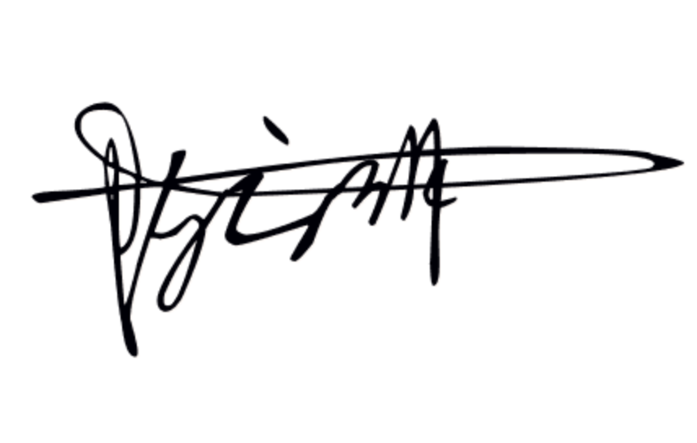

Yunlin Chen

Technical Director at Mobvoi AI Lab.

yunlinchen@mobvoi.com

https://scholar.google.com/citations?user=VR-gvoIAAAAJ&hl=en

Mobvoi Corporation | Ronghui, Haidian, Beijing, 100000, China